

ITW-II End Semester

Project Report



Submitted by:

Ankan Bohara (Roll N0.-16075060)

Prashant Sharma (Roll No.-16075065)

Table of Contents

* Abstract
* Introduction
* Motivation
* Project Overview
* Contribution
* Bibliography

Abstract

The title of our project is “Surmount JEE”. This project is an educational web application which provides users the content, quizzes and other robust features to boost their preparation for Joint Entrance Exam.

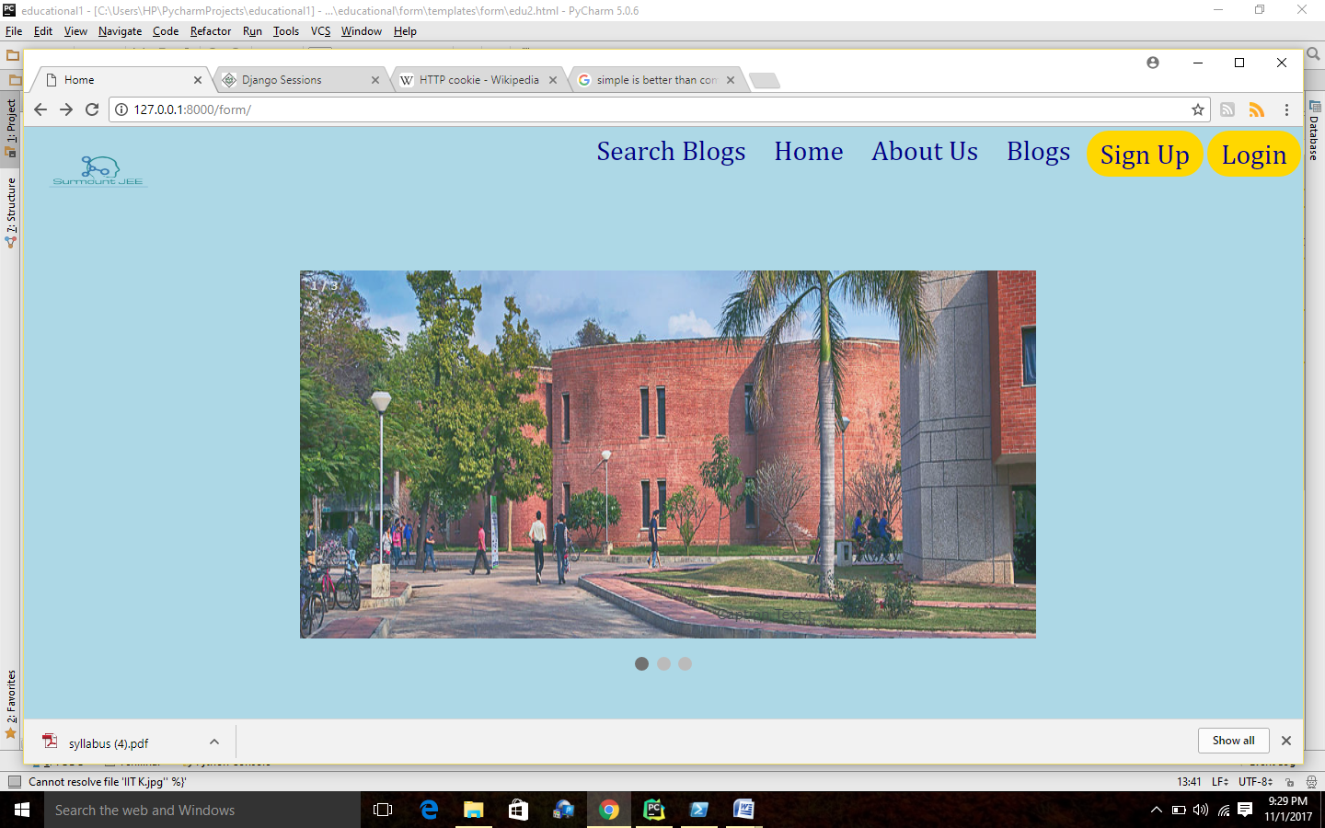

Introduction

The title of the project is a clear indication of our objective to make this web application. This web application server the most basic needs of a student. He would find the best content for the JEE. The site provides the exhaustive preparation material. The site offers fast doubt clearance, mind boggling quizzes and numerous other features. The feature that distinguishes it from the rest of other similar applications is student gets a full performance analysis after each exam. This not only enriches its strong topics but also provide a helping hand in the weak areas.

Feeds and notifications, updates the knowledge and remains in touch with recent activities.

Highly scrutinized blogs by experienced authors make one’s concept crystal clear.

Our project is made in the Django framework. The extraneous features of Django and the robust libraries are keys in the development of our project.

Motivation

The main motivation in choosing this project lies in our background. The difficulties we faced during our preparation time, becomes instrumental in developing new features in our project. There are so many other websites which provide the materials for preparation but failed at the point of their credibility. All blogs under one shed tempted us to choose this project.

The due credit should also be given to the most fascinating features of Django that tempted us to make a step toward web development.

Project Overview

**PRELIMINARY**

**Django** is an open source web application frame work written in Python. The primary goal of Django is to make the development of complex, data-based websites easier. Thus Django emphasizes the reusability and plug ability of components to ensure rapid developments. Django consists of three major parts: model, view and template.

* **Model** is a single, definitive data source which contains the essential field and behavior of the data. Usually one model is one table in the database. Each attribute in the model represents a field of a table in the database. Django provides a set of automatically-generated database application programming interfaces (APIs) for the convenience of users.
* **View** is short form of view file. It is a file containing Python function which takes web requests and returns web responses. A response can be HTML content or XML documents or a “404 error” and so on. The logic inside the view function can be arbitrary as long as it returns the desired response. To link the view function with a particular URL we need to use a structure called *URLconf* which maps URLs to view functions.
* Django’s **template** is a simple text file which can generate a text-based format like HTML and XML. The template contains variables and tags. Variables will be replaced by the result when the template is evaluated. Tags control the logic of the template. We also can modify the variables by using filters. For example, a lowercase filter can convert the variable from uppercase into lowercase.
* **Python** is the language used to build the Django framework. It is a dynamic scripting language similar to Perl and Ruby. The principal author of Python is Guido van Rossum. Python supports dynamic typing and has a garbage collector for automatic memory management. Another important feature of Python is dynamic name solution which binds the names of functions and variables during execution.

**An overview of the Project**

Our desired result of the preparing an educational website is an integrated web-based system combining several current systems in use. It includes the following components:

* Django’s session framework: We have included the django’s session framework to create sessions for the logged in users. This helps us in saving various important data that we receive from the clients. The data like feedback, enquiry etc. helps us to get in touch with our users and serving their needs.

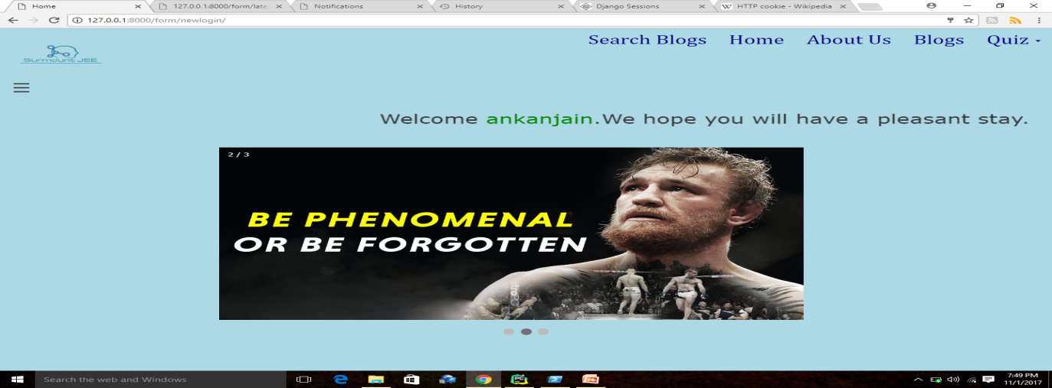

* Django’s Authentication Feature: This feature enables us to keep track of registered users who can access features of our web application. This also prevents the denial of fraudulent users who masquerade as the genuine users and try to get confidential details from our web application.

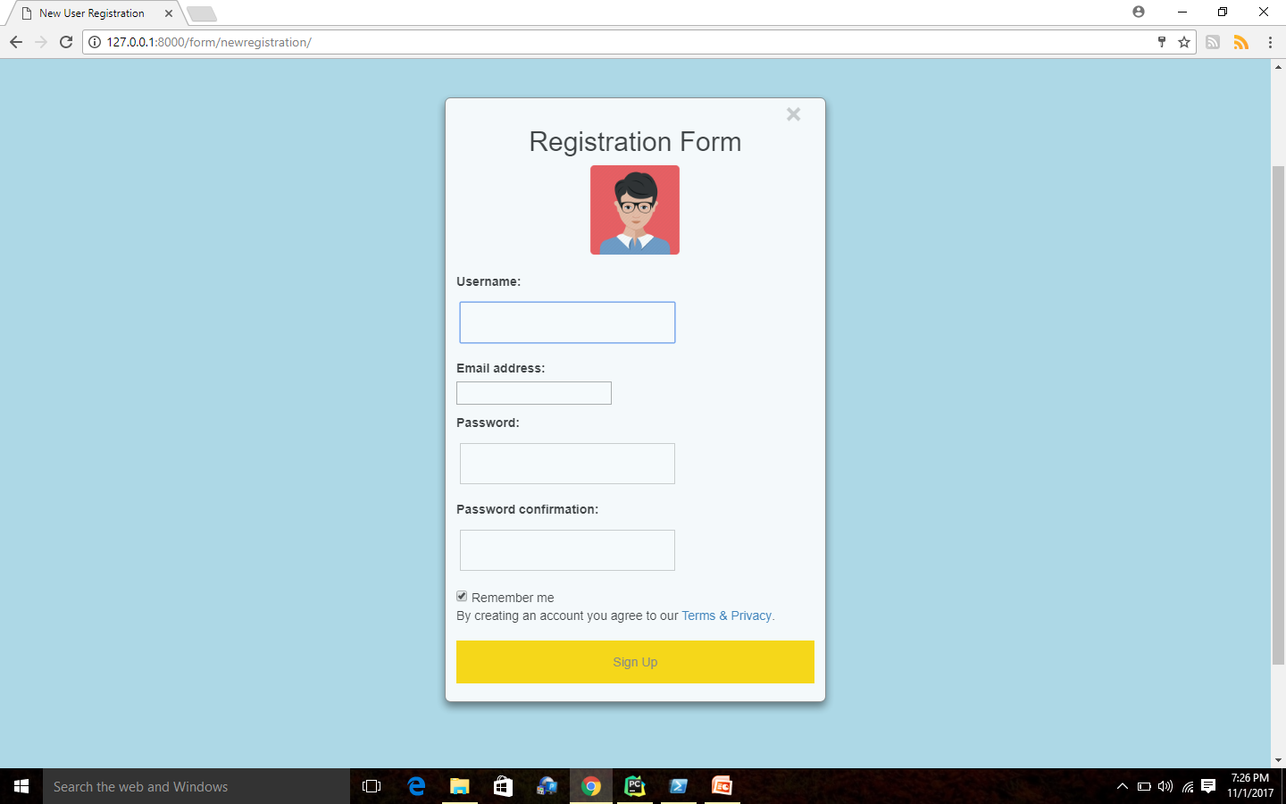

* Quizzes: Our web app provides access to the quizzes of type single option correct and multiple options correct to the users who logged in to our website. Quiz would get automatically submitted after a stipulated time set by the quiz setter. The user would be automatically directed to the result page. One can obtain certificate of completion with the score he obtained after completion of the quiz.

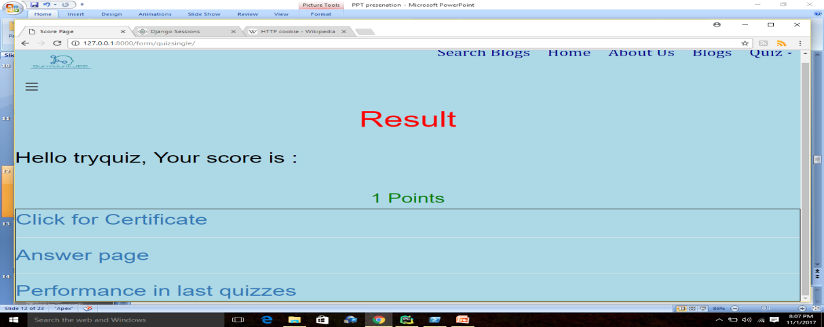

* Performance Analysis: A user who has successfully completed the quiz can see his/her performance in the last quizzes. From this feature user can monitor their progress. This helps in tracking their weak areas as we provide right answer to all the questions asked.

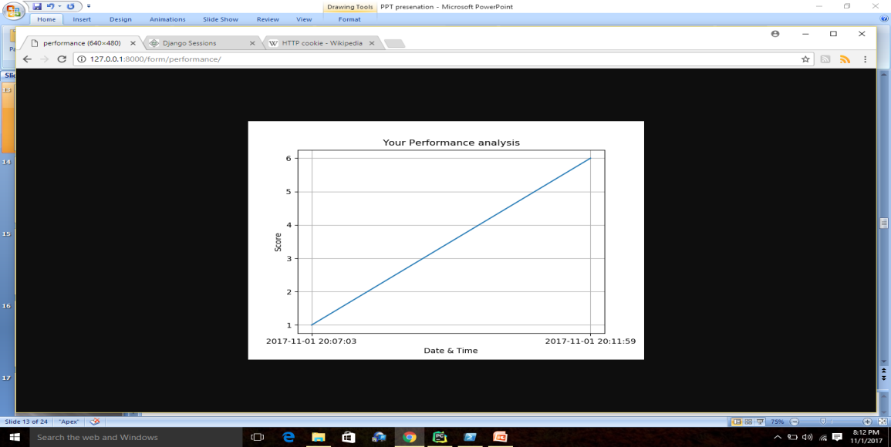

* Social Login Feature: We have included built in ‘social_django’ app in addition to our app ‘form’. This enables the user to login to our website from their **Facebook or GitHub account.** This is shown in the snippet of our web site below:

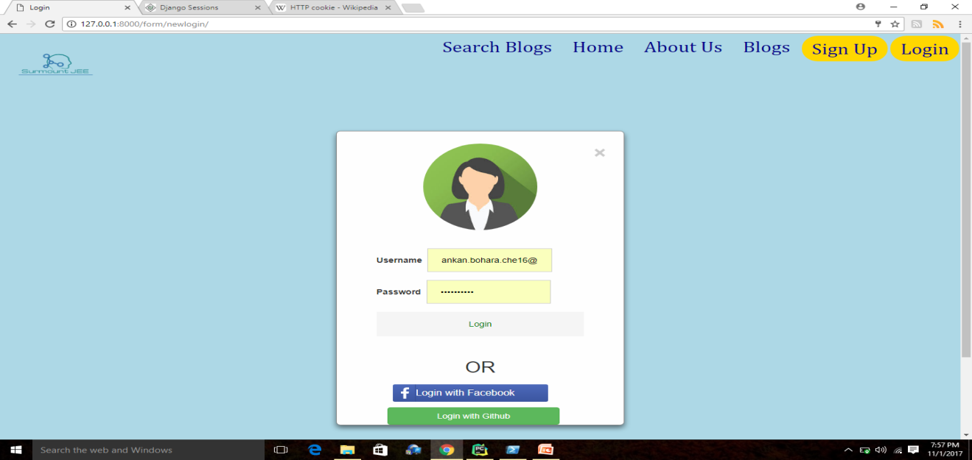

* Blogs and Search functionality in the blogs: Here authenticated user has the option to create the blog or read the blogs contributed by other users. One of the awesome facilities is that one can search the blogs by either username, blog topic or any other similar content.

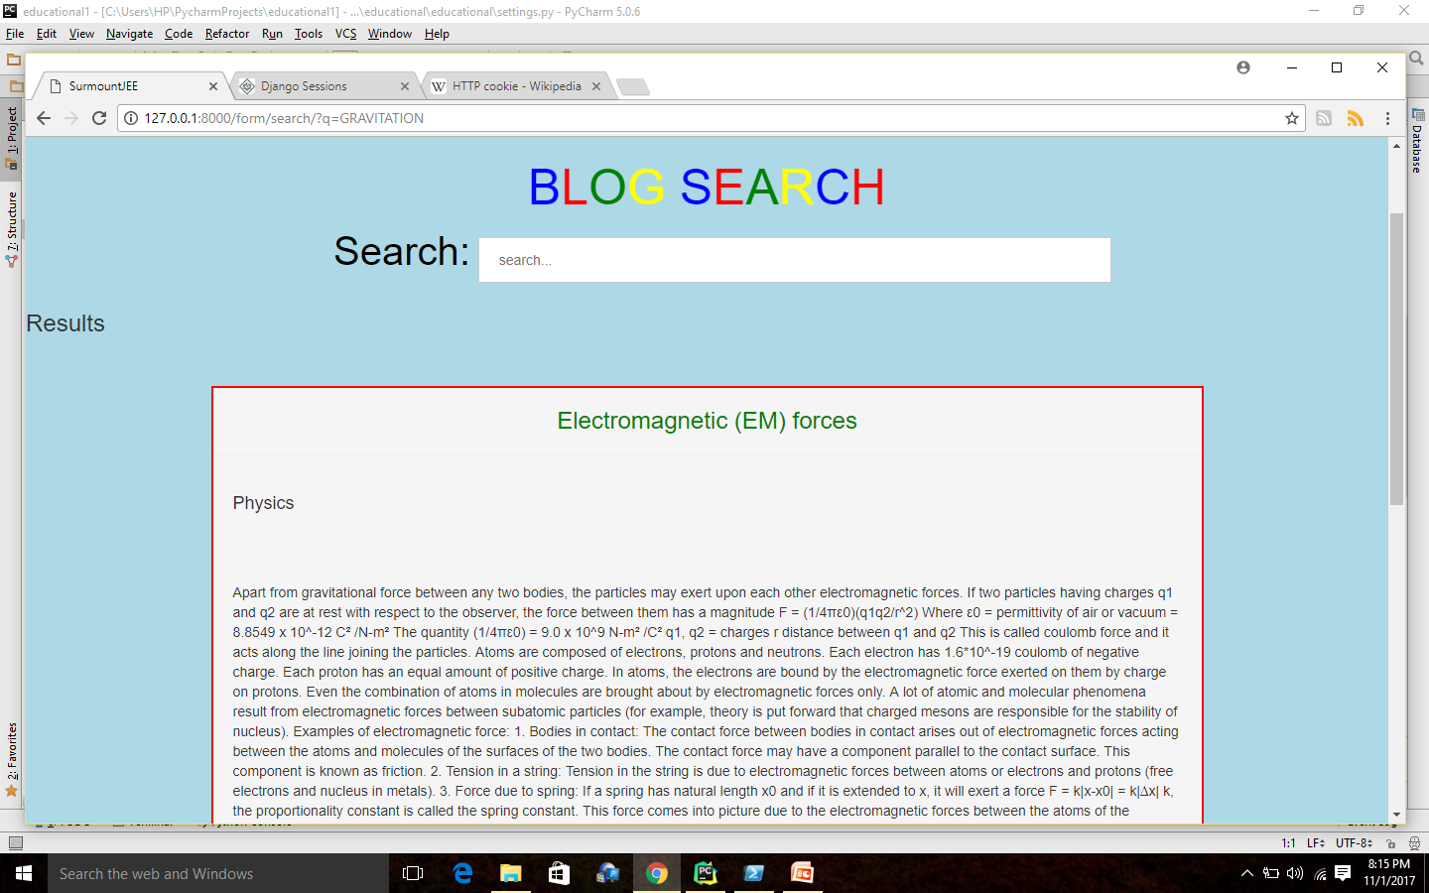

* RSS and Atom feeds: This is a sophisticated feature that uses the ‘django.contrib.syndiaction.views’. This feature helps the site managers to send any notification or feed to all the users.

Contribution

* **ANKAN BOHARA**
  + QUIZ PREPARATION
  + RESULT AFTER THE QUIZ
  + SOCIAL MEDIA LOGIN FEATURE-FACEBOOK
  + RSS AND ATOM FEEDS
  + USER REGISTRATION
  + BLOG,CONTACT FORM
  + MOSTLY BACKEND PART
  + PERFORMANCE ANALYSIS AFTER THE QUIZ

.

* **PRASHANT SHARMA**
  + FRONT END PART
  + SEARCH IN BLOGS
  + SOCIAL LOGIN FEATURE USING GITHUB
  + LOGIN,FEEDBACK FORM
  + AUTOMATIC SUBMISSION OF FORM ON COMPLETION OF QUIZ
  + ENABLE THE DOWNLOAD OF .PDF FILE
  + CUSTOM MIDDLEWARE
  + INTERNATIONALISATION

Bibliography

* <https://www.djangoproject.com/>
* <https://tutorial.djangogirls.org/en/django>
* <https://docs.djangoproject.com/en/1.11/>
* <https://tutorial.djangogirls.org/en/>
* <https://simpleisbetterthancomplex.com/>